Population Growth

Micro-organisms

Change the conditions and run the experiment to see how quickly the micro-organisms (microbes) divide and grow.

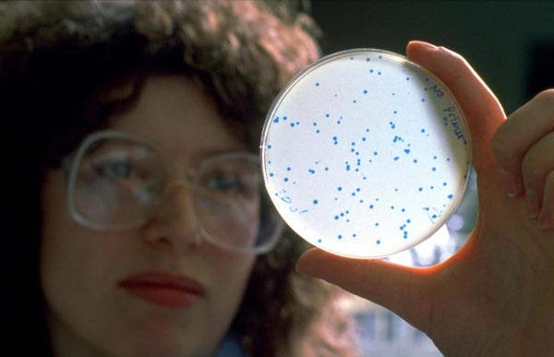

To make counting easy, a grid is provided that will let you estimate the total number of microbes present.

Design a table for your results. Include a prediction column which you should fill in before you run the experiment. A sample table is shown below.

Day | Predict number of microbes (x100 million) | Actual number of microbes (x100 million)
1
2
3
4
5
6
7

- What conditions allow the microbes to divide quickly?

- What conditions stop the microbes dividing?

- Draw a graph to show how the number of microbes changes with time.

